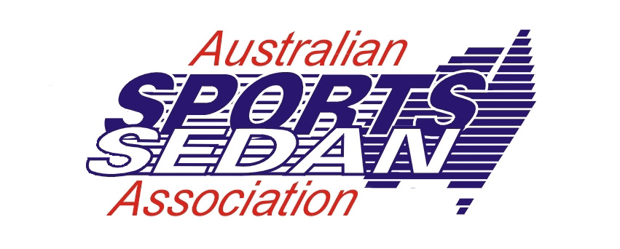Sandown International Raceway
Category
Race No.

19 - 21 JULY 2019

PIT LANE DISCLAIMER

EXCLUSION OF LIABILITY, RELEASE AND ASSUMPTION OF RISK

In exchange for being able to attend or participate in the event, I agree:
- to release Confederation of Australian Motor Sport Ltd ("CAMS") and Australian Motor Sport Commission Ltd, promoters, sponsor organisations, land owners and lessees, organisers of the event, their respective servants, officials, representatives and agents (collectively, the "Associated Entities") from all liability for my death, personal injury (including burns), psychological trauma, loss or damage (including property damage) ("harm") howsoever arising from my participation in or attendance at the event, except to the extent prohibited by law;
- that CAMS and the Associated Entities do not make any warranty, implied or express, that the event services will be provided with due care and skill or that any materials provided in connection with the services will be fit for the purpose for which they are supplied; and
- to attend or participate in the event at my own risk.

I acknowledge that:
- the risks associated with attending or participating in the event include the risk that I may suffer harm as a result of:
- motor vehicles (or parts of them) colliding with other motor vehicles, persons or property;
- acts of violence and other harmful acts (whether intentional or inadvertent) committed by persons attending or participating in the event; and
- the failure or unsuitability of facilities (including grand-stands, fences and guard rails) to ensure the safety of persons or property at the event.
- motor sport is dangerous and that accidents causing harm can and do happen and may happen to me.

I accept the conditions of, and acknowledge the risks arising from, attending or participating in the event and being provided with the event services by CAMS and the Associated Entities.

Driver/Pit Crew Name  (Please print clearly) | Driver/Pit Crew Signature | Date of Birth | Wrist Band No.

Name: | Signed: | Date of Birth: | No.
Name: | Signed: | Date of Birth: | No.
Name: | Signed | Date of Birth: | No.
Name: | Signed | Date of Birth: | No.
Name: | Signed: | Date of Birth: | No.
Name: | Signed: | Date of Birth: | No.

I ………………………………………..Being the Entrant or his agent of Car No. ……….. In Category ………………….. declare that the persons
Whose names and signatures appear above are attached to my team and I also declare that the wrist bands numbered above will only be distributed to those persons.

Signature:…………………………………………………………………… Date: ………………………………………………………………….

Wrist Bands are only valid if attached to the wrist of the person whose signature appears on this disclaimer.
Wrist bands are valid for the length of the meeting and if lost a replacement cannot be issued.
For persons under the age of 18 years parent/guardian consent must also be completed. Please obtain from the wrist band issue point at Document Check.

